**FUNCTIONAL REQUIREMENT SPECIFICATIONS DRAFT 1.0**

**Project Name: TY-Mac Web Learning System**

**Date: 07-10-2021**

**1.INTRODUCTION**

This document describes the Functional Requirements for the creation of a Web based Online Educational Platform named TY-Mac. The purpose of this document is to capture the various requirements of the project and the system to be developed.

Both Functional and Non-Functional requirements are captured in this document. It also serves as the input for Design & Development. This structure of the system is in such a way that it does not require any applications/installations from the User end. To access the system only a browser is required.

**2.PRODUCT SCOPE**

The Scope of this project is to develop a live learning platform that is secure, visually appealing, engaging and reflects all the values and vision withheld by TY-Mac.

**2.1 Product Functions**

The objective behind this project is to provide a user-friendly environment to everyone and give a chance to acquire knowledge on various courses provided in TY-Mac irrespective of where they are and the students can register themselves with the system based on their interested topic and feedback/recommendations given by other students.

The system should provide all functionalities similar to a traditional training methodology based on Users and User activities such as choose a course, being register for a class, appear for class in virtual class room, should raise a question, and use of advance technologies like live streaming, audio – visual communication between Teacher and Student. Other functionalities are specified for different application users (Refer section 3).

**2.2 User Classes and Characteristics**

There are mainly three classes of Users for a Web training/learning Application Platform.

1. **Learner/Student**, who will come to TY-Mac Portal to choose a course through self -registration, attend a live class, view and download course content, provide feedback etc.
2. **Teacher/Instructor,** who is allowed to conduct a live class, share white board and screen, upload a course content, notes, assignments etc.
3. **Content Creator/Administrator**, who is allowed to control learning activities by the functions like creating predefined accounts for Instructors, schedule training, assign course and Instructor for Students etc.

The below diagram represents the context level diagram of the system.The main actors in the proposed website are Administrator, Instructor and Student.

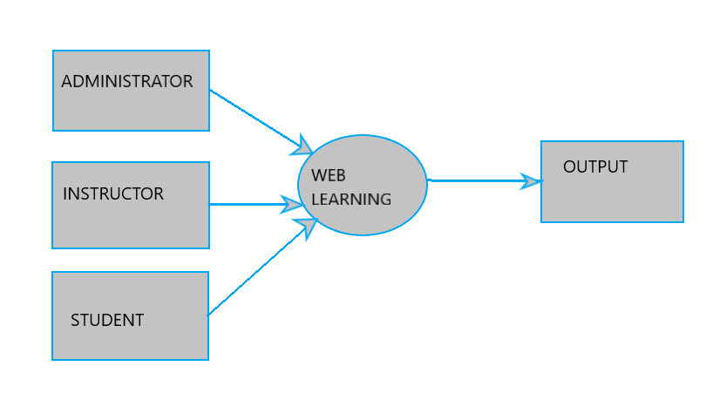

Fig 1. Data Flow Diagram.

**3.FUNCTIONAL REQUIREMENTS**

The key personnel for the proposed system are Content Creator, Instructors & Students. The Functional Requirements for the Website and each Users are explained below:

**3.1 Requirements on Website Contents.**

The following are the requirements for the TY-Mac Website.

The website information shall contain,

1.Website Navigation Menu

2.The information about the TY-Mac Way

2. About us Page

3. Contact us page

4. Option to Apply to be an Instructor

5.Link to Social media pages

6.Partners page

7.Testimonials page

8.Courses offered with respective Instructor Image/Information

9.Course catalogue.

10.Option for students to provide name/email address to learn more about the courses offered (Registration)

11.Provision to Login for the Users

* The website design shall be minimal, sleek and elegant.
* The platform shall be incredibly easy to use.

**3.2. User Content Creator**

Content Creator/Administrator is a super user who has the ability to create/remove Instructor or Students account. This user should also have the facility to add/edit/delete courses, course contents etc.

|  |  |  |
| --- | --- | --- |
| Sl.no | Short Description | Description in Detail |
| 3.2.1 | Admin/Content Creator Privileges | •Content Creator shall have the privilege to manage the website,courses and thereby maintain the overall performance of the TY-Mac portal.Below are the functionalities:  •Admin Account  •Scheduling Sessions  •Managing Assignments  •Create Instructor Account  •Managing Courses  •Track all information and details of students and instructors. |
|
|
| 3.2.2 | Upload new course | •Content Creator shall have the right to upload course topics and subtopics/sub sections, preparing contents of courses.  •The supporting format shall be video, pdf, Powerpoint. |
| 3.2.3 | Update / remove/review existing Courses | •Content Creator shall have the privilege to update or remove the existing courses that he/she has made. |
| 3.2.3 | Assign course to Instructor | •Content Creator shall have the privilege to assign courses to Instructors.  •He/she shall have the right to see the list of  Courses assigned to each Instructors  •He /she shall have the right to track all the information and details of live sessions,chats,classes. |
| 3.2.4 | Schedule course/session times in different time zones | •Content Creator shall have the right to  schedule Course/session timings in different time zones based on Students preference.  •Right to schedule live class  •Right to create lesson plans. |
| 3.2.5 | Announcement/Events | •Content Creator shall have the right to update any latest announcements regarding existing Courses/New courses in the Portal. |

**3.3 User Instructor**

An Instructor/Teacher is a second type of user in this application. Instructor shall be given the option of managing a single class/multiple classes, a student /group of students. A Teacher shall be given a live chatting platform between teacher and students while the lesson is being taught or for a live session. The following are the functional requirement for the User-Instructor.

|  |  |  |
| --- | --- | --- |
| Sl.No | Short Description | Description in Detail |
| 3.3.1 | Login to pre-created account | •Teacher shall have the right to login to his/her pre-created account. |
| 3.3.2 | View course contents/topics/subtopics | •Teacher shall be able to view his Course content/topics and subtopics in his/her own dashboard  •Upcoming sessions to be taught |
| 3.3.3 | View Session Scheduled | •Teacher shall be able to see the pre-scheduled live sessions/classes to be taught. |
| 3.3.4 | Conduct Live class | •Teacher shall have the right to conduct/host a pre-assigned Live class Session.  •Provision to mute own mic as well as students.  •Provision to share his/her own screen. |
| 3.3.5 | Ability to see students enrolled in a course | •Teacher shall have the right to see the students enrolled for the respective course. |
| 3.3.6 | Ability to see students list and their chat list while in class. | •Teacher shall have the right to see his/her own students  •Shall have the right to chat with his/her own student(those who enrolled for the respective courses) in real time.  •shall have the right to view his/her own student chat list. |
| 3.3.7 | Email Notification | •Teacher shall be notified when a student registered for his/her subject/course. |
| 3.3.8 | Reminder Notification | •Teacher shall receive a reminder notification for the next pre-scheduled Live session. |
| 3.3.8 | Ability to communicate with the students enrolled for the course | •Teacher shall have the ability to communicate with the registered students for the respective courses. |
| 3.3.9 | Provide Achievement Badge | •Teacher shall be able to provide an achievement badge to his/her own student for successful course completion/course session. |

**3.4. User Student**

Student users belong to their learning course and can access their assignments, registered course contents/subtopics etc.

|  |  |  |
| --- | --- | --- |
| Sl.no | Short Description | Description in Detail |
| 3.4.1 | Student Registration for a course | •Any students shall have the right to register on the website using Register button  •Student shall be able to create an account with first name/last name,User name & Password |
| 3.4.2 | Student Login | •This is the login button where students can login to the system. |
| 3.4.3 | Ability to view course contents | •Student shall have the right to view the registered courses |
| 3.4.4 | Ability to join Live Session classes | •Student shall have the right to join Live session classes after successful registration with the respective course. |
| 3.4.5 | Submit/replace student assignment report | •Student shall have the right to submit /replace his/her own assignment report. |
| 3.4.6 | Student event screen | • Student shall be able to view his/her scheduled sessions. |
| 3.4.7 | Student Inbox Screen/ability to chat with the Teacher during Live session | •Student shall be able to view the chat box that had with the Teacher  •Student shall be able to  clear the doubts in the Live session itself through a real time chat box. |
| 3.4.8 | Student Class Recording | •Student shall have the right to access his/her class recordings |
| 3.4.9 | Student Live feedback | •Provision for the Student to provide live feedback using Thumbs up/Thumbs down. |
| 3.4.10 | Student Achievement Badge | •Provision for the student to view his/her own achievement badge for course completion/course session. |
| 3.4.11 | E-mail confirmation | •Student shall receive a confirmation email for successful course registration. |
| 3.4.12 | Reminder Notification | •Student shall receive a reminder notification for scheduled Live sessions. |

**4.USE CASE DIAGRAM**

**4.1 USE CASE Diagram for the Content Creator**.

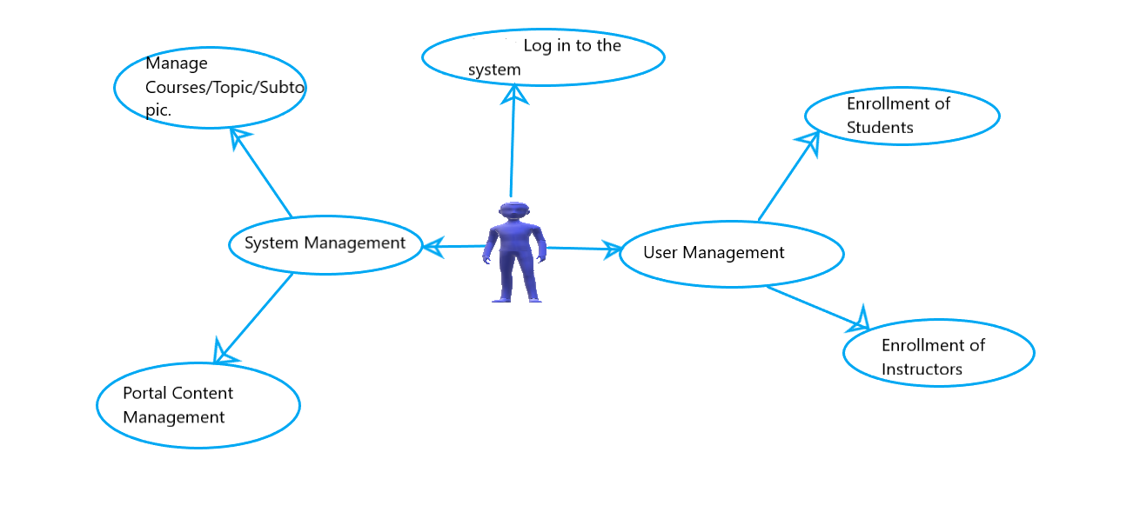

**4.2 USE CASE Diagram for the Instructor**

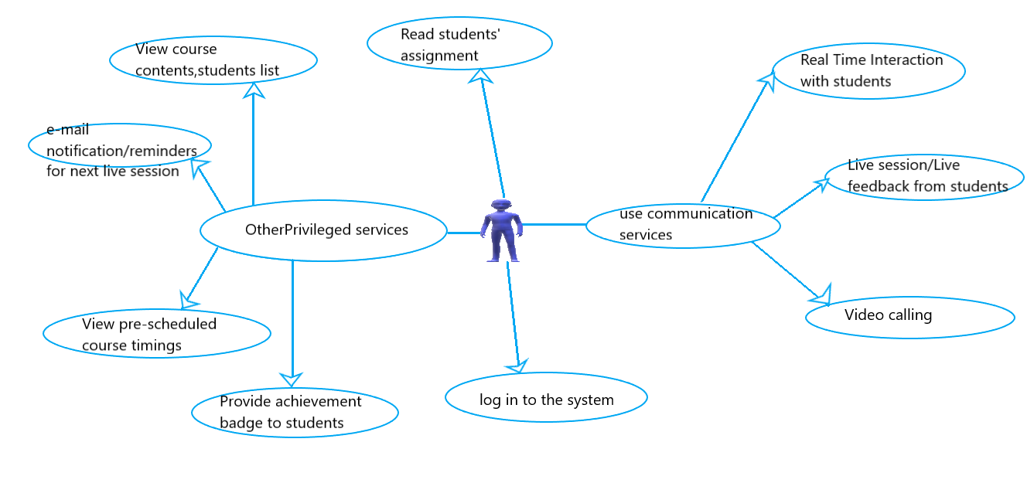

**4.3USE CASE Diagram for the Student**

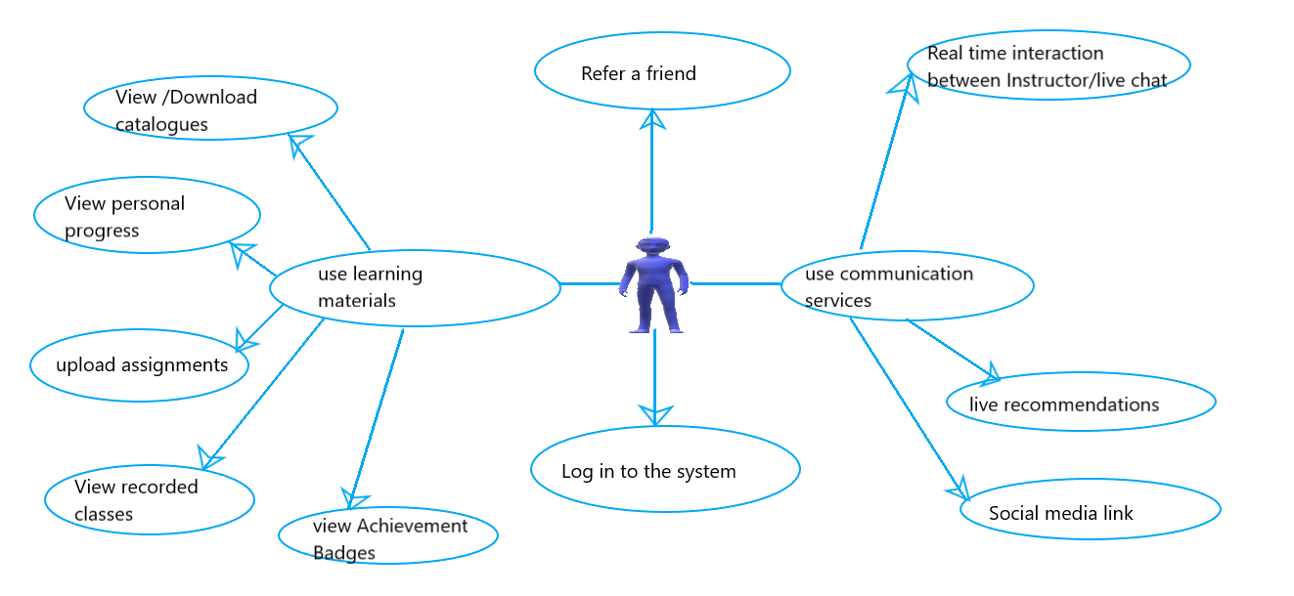

**4.4 USE CASE DIAGRAM FOR DIFFERENT ENTITIES**

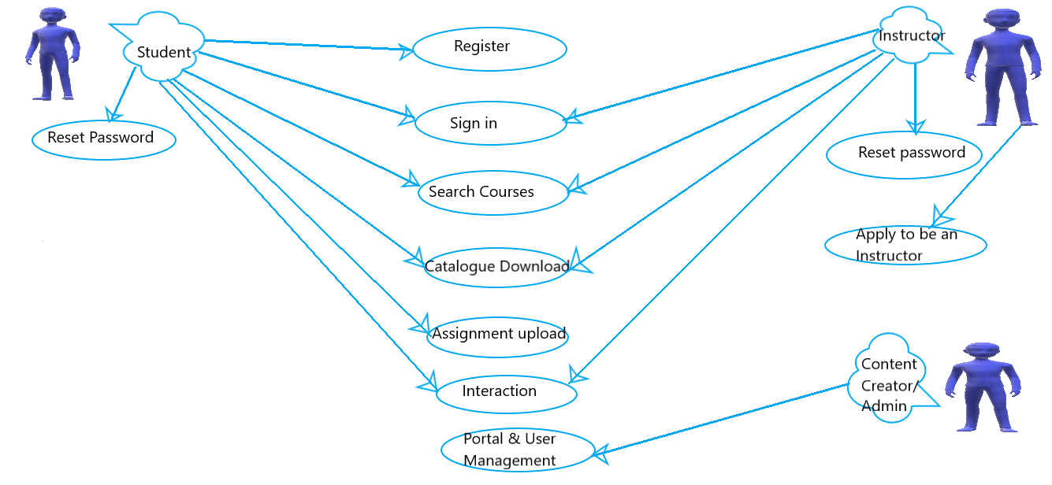

**5.PROPOSED DESIGN/WIREFRAMES (by TY-Mac)**

The proposed Wireframes of Ty-Mac portal can be viewed through below link:

<https://app.moqups.com/>

**6.TY-Mac PERSONALISED RECOMMENDATION ENGINE**

The system provides a provision to the Student to recommend /give a feedback for a course session. At the end of each session, the teacher is able to see the understanding of students for that particular topic in each session.

6.1 How can the student provide recommendations?

•# of Thumbs Up & # of Thumbs down displayed in a graph form

Graph will display:

1. # of Thumbs Up & Thumbs down
2. % of topics understood

•Based on the number of dislikes for a topic, suggestion to review topic or not is made

6.2 Workflow of TY-Mac personalized recommendation engine

1. Calculate recommendations based off of # of thumbs up/thumbs down
2. Recommendations are linked to teacher’s account live session
3. Recommendations are linked to a student’s account live session
4. Sub topics sync with live session & recommendations

[Note: Workflow Image can be viewed in the shared document from TY-Mac or <https://app.moqups.com/>]